1. Write a program to perform addition, subtraction, multiplication, division, and modulus operations on two user-provided integers.

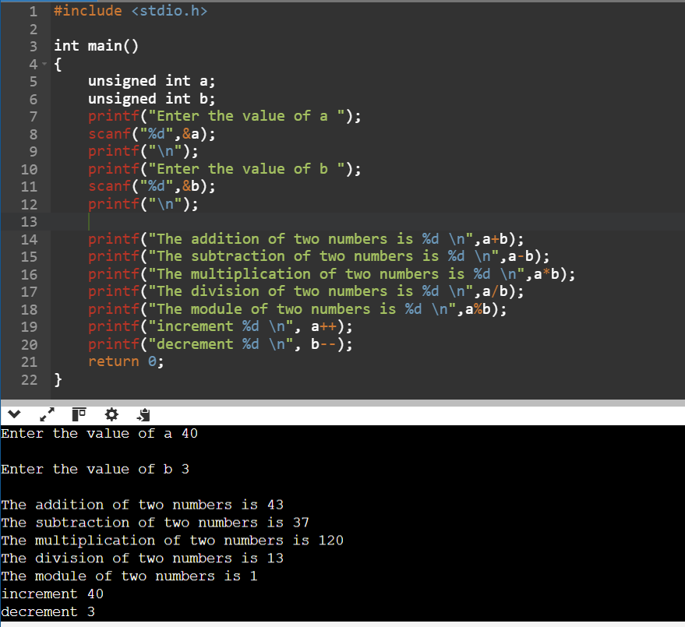

2. Write a program to calculate the average of five integers provided by the user.

3. Compute and display the area and perimeter of a rectangle given its length and width.

4. Write a program to calculate the compound interest using the formula:

A=P×(1+(r/100))^n

where P is the principal, r is the rate of interest, and n is the time period.

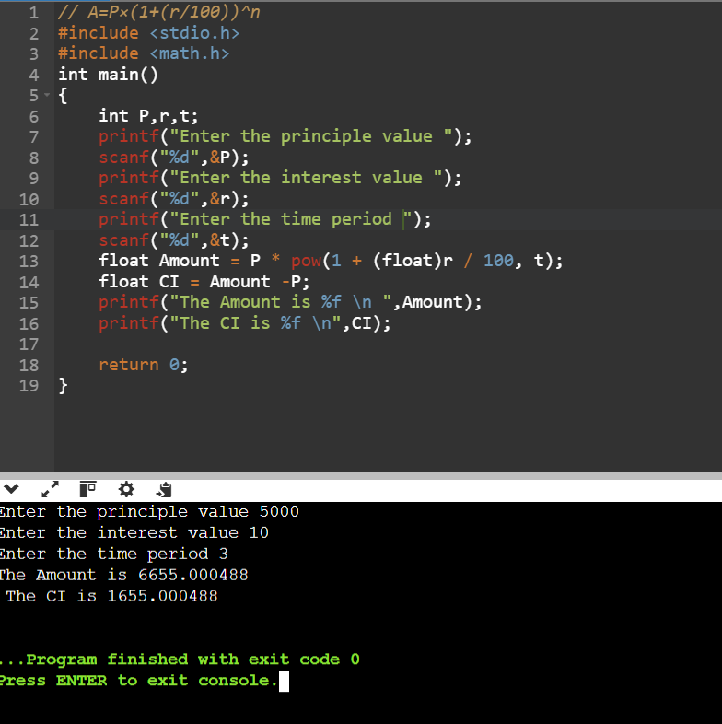

5. Write a program to convert a temperature from Celsius to Fahrenheit using the formula:

F=(9/5)*C+32

6. Write a program to swap the values of two variables without using a third variable, relying only on arithmetic operations.

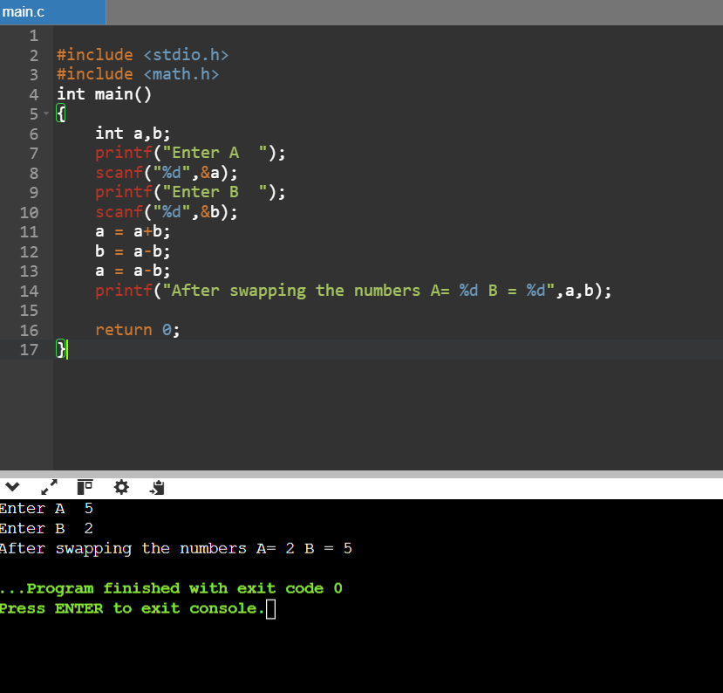

7. Write a program to find the sum of the digits of a given three-digit number.

8. Calculate the hypotenuse of a right triangle given the lengths of the other two sides using the formula:

C = root over of (a^2 + b^2)

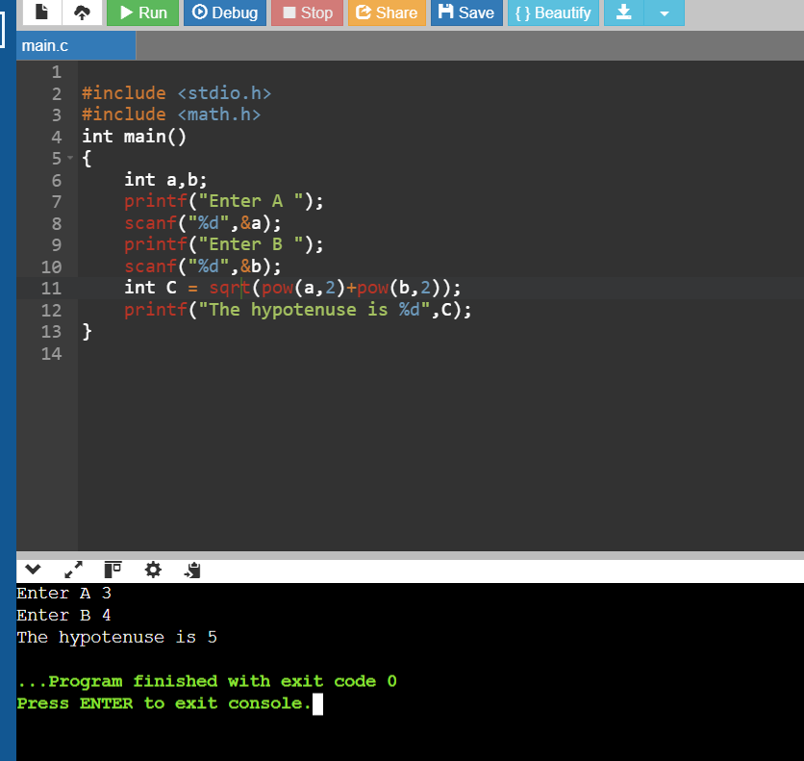

9. Write a program to calculate the circumference and area of a circle given its radius. Use the formulas:

* Area: πr^2
* Circumference: 2πr
* A screenshot of a computer program

  Description automatically generated

10. Write a program to calculate the profit or loss made on a transaction given the cost price and selling price of an item.

1. **Compare Two Numbers:**  
   Write a program to check if two integers are equal, not equal, greater than, or less than each other using relational operators.

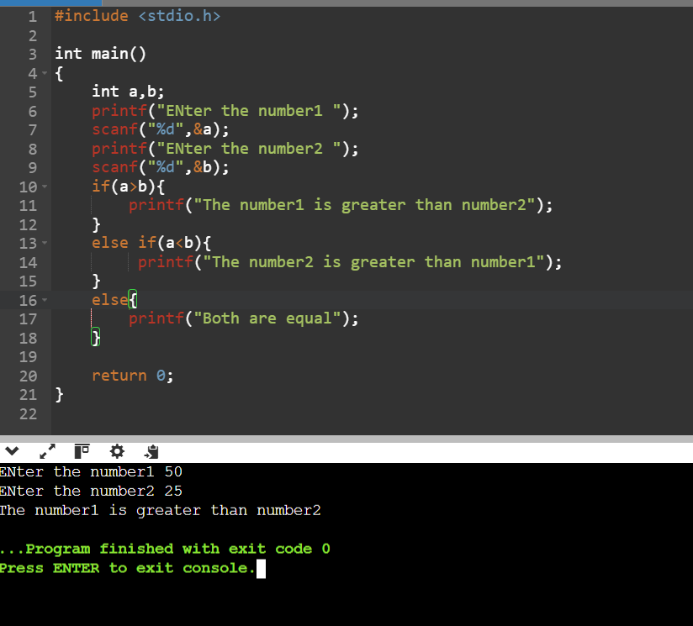

1. **Eligibility for Voting:**  
   Determine whether a person is eligible to vote based on their age (age must be greater than or equal to 18).

1. **Triangle Validity Check:**  
   Given three sides of a triangle, use relational operators to check if the triangle is valid (the sum of any two sides must be greater than the third side).

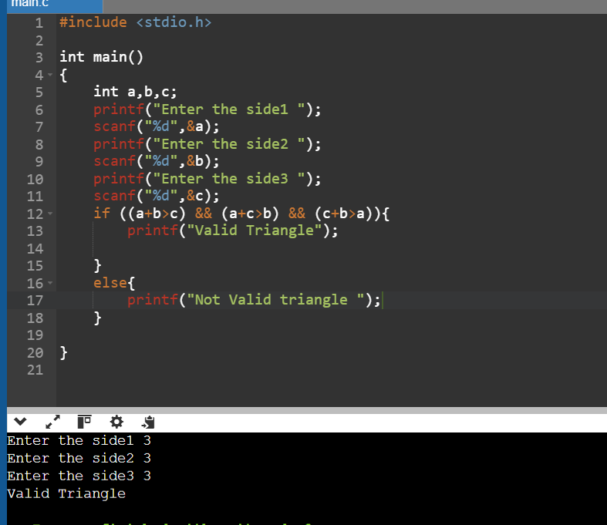

1. **Student Grade Comparison:**  
   Compare the marks of two students to determine who scored higher, or if they have the same marks.

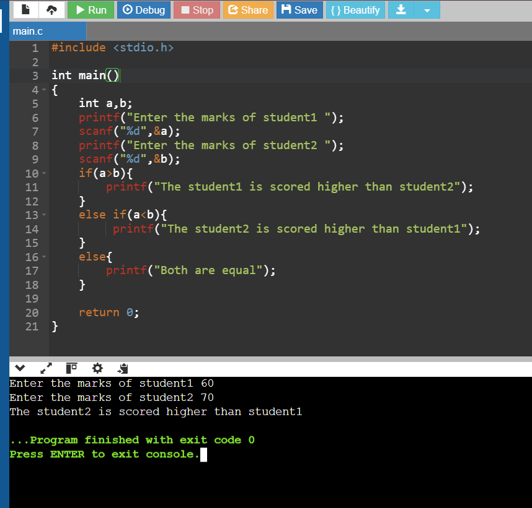

1. **Find the Largest of Three Numbers:**  
   Write a program to compare three numbers and determine the largest number using relational operators.

1. **Leap Year Check:**  
   Use relational operators to determine if a given year is a leap year (divisible by 4 but not by 100 unless divisible by 400).

1. **Temperature Alert:**  
   Write a program to check if the temperature exceeds a threshold value (e.g., greater than 40 degrees Celsius) and display an alert message.

1. **Password Strength Validation:**  
   Given the length of a password, check if it meets the minimum requirement of 8 characters using relational operators.

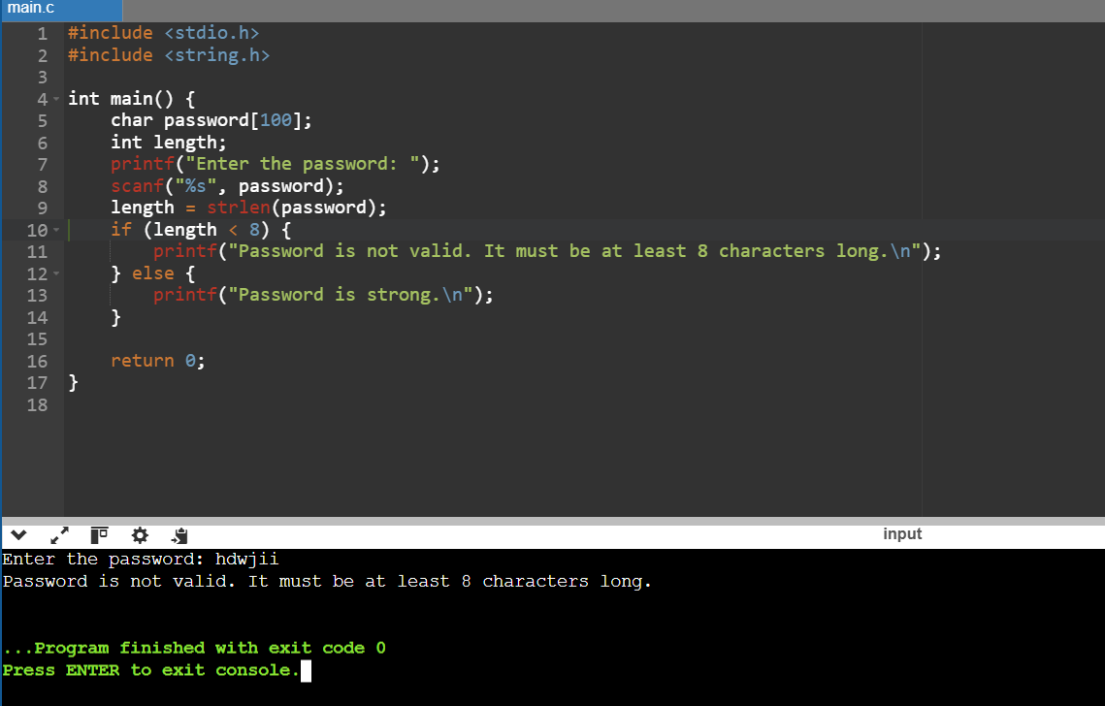

1. **Check Divisibility:**  
   Write a program to determine if one number is divisible by another using relational operators.

1. **Admission Criteria:**  
   Check if a student meets the criteria for admission to a course based on their age (greater than or equal to 18) and marks (greater than or equal to 50).

